Withington Wheelers Beginners guide to Time trials

Time trials
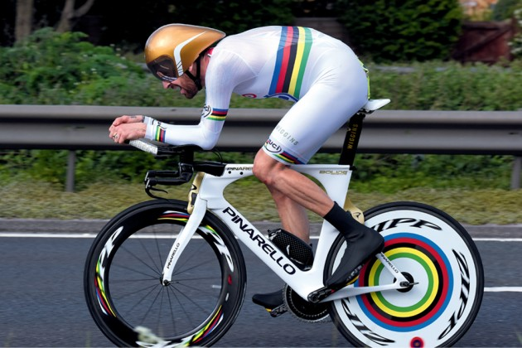
A time trial is where you race on your own, unpaced for a given distance. Time trials distances are 10 miles, 25, 50 and 100 miles and 12 and 24 hours. The most popular distances are 10 and 25 miles.
There are two main types of time trials, Club events and Open Events. Club events are more informal races only for members of a club and Open events are more organised events that are open to all riders. Most riders start off riding a Club 10 mile time trial, this is a good introduction to racing, with no pressure.

Club events
These are run by a cycling club for their own members only. Withington runs several 10 mile time trials and a couple of 25's during the season and the dates of these appear in the Club Newsletter.

Club time trials are pretty informal affairs; you just turn up and ride. The meeting place for a Club event (the HQ) is often a pub car park, changing facilities are a luxury! If you turn up about 45 minutes before the start of the time trial, you will have time to meet up with club mates, put your name down on the start sheet, get your number and starting time, pay your entry fee (only about £2) and still have time to warm up. When you have entered, pin your number on and make your way to the start. Aim to reach the start a few minutes before your start time, and then wait near the start timekeeper until it is your time to start.

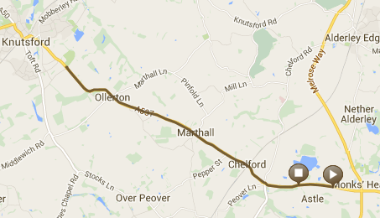
Riders will start at minute intervals, for a club event there may be only a dozen or so riders, whilst for an open event there may be 120 riders. You will be held up on your bike at the start, counted down 5,4,3,2,1, and then you are off. There may be marshals around the course, but you shouldn’t rely on them. If you don’t know the course, look at it on the internet. Most courses are ‘out and back’ which means that half way round you turn (usually at a roundabout) and retrace your route to finish near the start. There will be a timekeeper at the finish to record your time and your result will be relayed to the results board at the HQ.

Some clubs are happy for riders from other clubs to ride in their own club event depending on how amenable the promoting club is. There are regular mid-week club events that specifically welcome riders from other clubs. Stockport Clarion, Westmead and Seamons organise 10’s on Cheshire and Wigan Wheelers and Prescot Eagle run mid-week 10’s on the Rainford bypass.

Riding a time trial
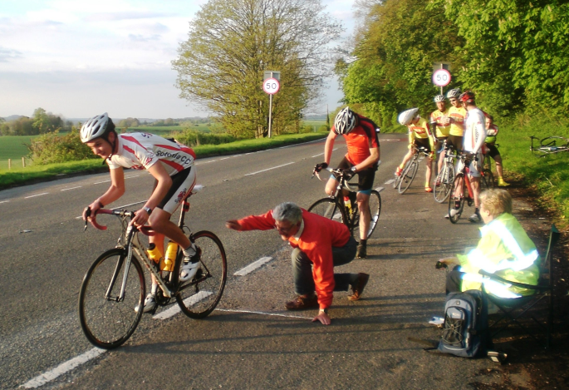
When you get to the start, you set off at the exact time that you have been allocated e.g. 7.14pm. Another competitor will have started a minute in front of you and there will be another rider starting a minute behind you. Riding a time trial is simple; start, ride by yourself over the race distance, then finish! Riding a time trial quickly is a bit harder, you need to keep a fairly even pace throughout the race. Most novices start way too fast then fade badly in the second half. A target time for novices is 'evens' (20mph) which gives a time of 30 minutes for a 10 mile time trial and 1hr 15m for a 25.

This is an extract from the CTT web site on riding your first time trial and why we race.

“Thirty seconds," the timekeeper calls out. The starter holds you up while you clip into your pedals. Deep breaths. "Ten seconds." Your pulse is rising, your mouth goes dry. "Five, four, three, two, one..." You're off! Out of the saddle, you're powering down the road to get on top of your gear.
For the next half an hour your lungs will work like bellows. Your legs will strain on the pedals. Your nose will run. You'll be effortlessly overtaken by a skin suited cycling machine who set off four minutes back, his disc wheel roaring like a Star Wars TIE fighter.
At the finish you'll suck in ragged gasps of air, feeling so shattered you want to be sick. So you'd be forgiven for asking: where's the fun?
Well, it's nice when you stop. But there is more to it than that. Once you've got your breath back, your body is swimming with endorphins. It feels good and at some primal, work-ethic level, it's satisfying to have ridden at 100 per cent capacity, to have learned where your limits are. There's a sense that you've used the time productively, having seized the day rather than let it drift by.
It doesn't matter what your fitness level is, whether you're 22 or 82, male or female. If you can ride 10 miles on a public road then you can ride a time trial. It's not like a road race, where if you fall off the pack your race is over. Since the slower riders set off first, finish times cluster together.
You'll automatically get your personal best time (PB) in your first time trial. Whether it's 31:07 or 25:12, that's your target to aim at next time. It doesn't matter what time anyone else got - first and foremost in a time trial, you're racing against yourself.

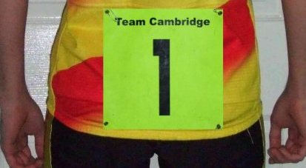
Race etiquette
There are some rules in time trialling, not many, but they are there for your safety and to ensure fair play.
Clothing needs to cover at least the upper arms and mid-thigh, no advertising is allowed on clothing i.e. no trade team jerseys.
You need to display your number prominently on your lower back. It is made of bright, reflective material, so should be low enough to be visible from the rear.
You must sign the signing-on sheet, for insurance purposes, etc.
The onus is on you to find your way around the course.
You must observe the rules of the road, the Highway Code and ride safely; you are responsible for your own safety.
No earphones are allowed, they are considered distractive.
You must ride alone and unpaced. If a rider passes you, the onus is on you to drop to about 50 metres back so that you do not take pace from the rider - you will be disqualified if you sit in behind the rider!
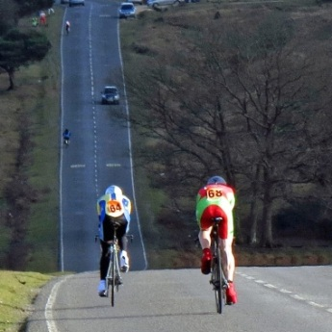
Please call out your number as you pass the finish, it will help the timekeeper.
Don’t do U turns near the start or finish or obstruct the view of the timekeepers.
Keep your head up at all times, many accidents are because of head-down riding.
If you use tri-bars, you need to come off them and hold your handlebars when negotiating roundabouts.
Take special care when joining or leaving a main road, many motorists don’t expect to see cyclists.
If you have an accident you must report it to the event secretary.
Your time will be shown on the result board after the event, please don’t ask the timekeeper for your time at the finish as they will be fully occupied timing in riders.
Don’t ride on the course if you are not racing as it confuses the timekeepers and the other riders.

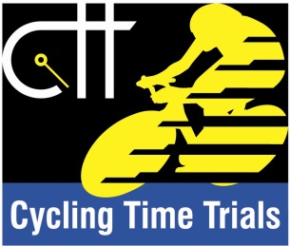
Governing body
The governing body for time trials in England and Wales is Cycling Time Trials (web site cyclingtimetrials.org.uk). CTT publish open time trial dates and courses and prescribe the rules of racing. On any summer weekend there will typically be around 30 open time trials taking place around the country and on Cheshire courses there will be one or two events each weekend.

The courses used for time trials are well known and have discretely marked starting and finishing locations. Courses must be very accurately measured for record purposes. Each course has a code number and these codes are well known to time triallists. All Manchester district courses start with a 'J' and the course J2/1 is a 10 mile course from Monks Heath along the A537 turning at Booths Hall roundabout and retracing back to the start.

Entering an Open event
Firstly you need to select the event. If you visit the CTT web site at cyclingtimetrials.org.uk, then select the Events option, you will see a list of all the open time trial events in the country. To search for local events, choose Manchester as the District. You will now see a list of all the events in the Manchester district. Each event has an entry like this:

The course code is J2/9 and if you click on this, you will get the course details; in this case it’s a Chelford-Cranage-Twemlow circuit.
The IE shown against the event means that you can enter by internet, just select the event then click the Enter Online button. If you do not enter on line, you can download an entry form, fill it in and send a cheque with the form to the event organiser.
The “H” for the event means that there is a handicap prize. Other symbols are used such as:
M – event for men W – event for women V – event for vets (40 upwards)

The closing date for most events is usually just under two weeks before the event. If the event is over-subscribed, the fastest entrants will be accepted, unless otherwise specified.

Once your entry has been accepted, you will receive a start sheet a few days before the event giving details of the course, prizes and your starting time. After the race you will receive a result sheet showing where you finished and confirming your time.

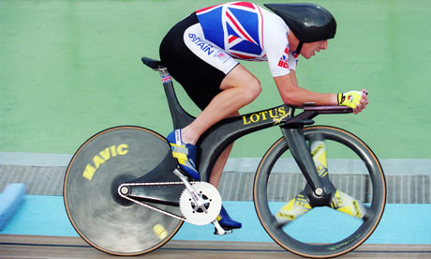
Here are Chris Boardman’s five top time trial tips:
- Don’t start too fast
- Get to know how hard you can ride using either perceived effort, heart rate or a power meter
- Do some training, two hour steady rides and shorter rides alternating 10 minutes hard, ten minutes easy
- Get aero – 80% of your resistance is air drag so go low on the bike, use tri-bars and train in the aero position
- Confidence - it’s not going to be pleasant and there’s no way it’s going to be an easy day.

Training
Everyone has their own way of training and you need to find what’s best for you and what makes you fast. Most cyclists buy a heart rate monitor for training; this makes it easier to judge how hard you are trying rather than relying on ‘feel’ alone.

The following are some of the more popular training sessions. Training can be on the road or on a turbo trainer, the current British Best All Rounder time trial champion, Adam Topham, does all his training on the turbo, including 4 hour turbo sessions!

Mileage/Base endurance - it is important to build up a base of ‘steady’ miles. If you are new to cycling it is more beneficial to build up a reasonable level of base fitness before jumping straight into racing. A good base for 10 mile time trials is perhaps 100 miles a week. If you do more, it will have some benefit; but it is not essential.
Threshold training – threshold is the fastest pace that you can hold for an hour – train for about 20 minutes at this pace, following a 15 minute warm up.
Interval training – for intervals you go at you fastest 20 minute race pace, but ride for only 5 minutes at this pace (1 interval), then go steady for 5 minutes, then another interval, then 5 minutes steady and continue until you have done say 5 intervals.

British Cycling gives further advice on training (web British Cycling Training Plans).
Joe Friel, co-founder of TrainingPeaks.com is the author of The Cyclist’s Training Bible, one of the most popular guides to training.
Andy Coggan’s book Racing and Training with a Power Meter is good if you are lucky enough to have access to a power meter.

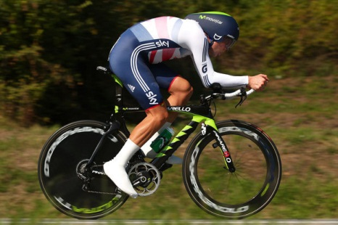
British time trial competition records

10 miles Alex Dowsett 17m 20s 34.6 mph
25 miles Matt Bottrill 45m 43s 32.8 mph
50 miles Matt Bottrill 1h 34m 43s 31.6 mph
100 miles Charles Taylor 3h 21m 31s 29.8 mph
12 hours Andy Wilkinson 317.9 miles 26.5 mph

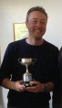
So that’s it, all the information that you need to ride your first time trial with the Withington Wheelers. All you have to do now is to turn up at an informal Club event and ride your first time trial. Very soon your confidence will grow and you will be back for more, setting personal bests and maybe winning some of the Withington Wheelers trophies. Start off by trying to beat a Club Standard time and win your first Withington Wheelers award.

Club Standards
Men Bronze Silver Gold
10 miles 27.00 24.30 22.30
25 miles 1.08.00 1.02.00 59.00
50 miles 2.25.00 2.10.00 2.00.00

Women Bronze Silver Gold
10 miles 30.00 27.00 25.00
25 miles 1.15.00 1.08.30 1.05.30
50 miles 2.41.00 2.24.30 2.13.00

